Comfort Sibuyi-577231

Kagiso Kgobane-577187

Tumiso Manamela-577081

DBD281 Project

Contents

**Introduction and background** 1

Normalization 1

Entity Identification and explanation: 2

Employee: 2

EmployeeAddress: 2

EmployeeTitle: 2

Customer: 3

CustomerAddress: 3

Transactions: 3

TransactionHistory: 3

Booking: 3

Hotel: 3

HotelService: 4

HotelAddress: 4

Room: 4

RoomReservation: 4

**List and description of objects in the database** 5

**Tables** 5

**Queries** 5

**Other objects** 5

# **Introduction and background**

Hotel Transel Vein(HTV) was founded in 1996 by a South African Entrepreneur, Jason Noah. HTV was established in SA. The company targets to accommodate tourists from all around the world who want to witness the attractions in SA.

HTV wanted a new database to manage their data. They mentioned that they were using the traditional ways of storing and managing their data but we created a database for them to effectively and efficiently use and manage their data.

The database consists of queries, triggers, views, procedures, cursors and functions that suit their needs.

Normalization:

* Each table in the database contains a single value and is a unique record.
* There are primary keys that uniquely identify a record as well as composite keys
* There are no transitive dependencies

Thus, establishing the completion of the 3rd normal form as seen in the ERD below: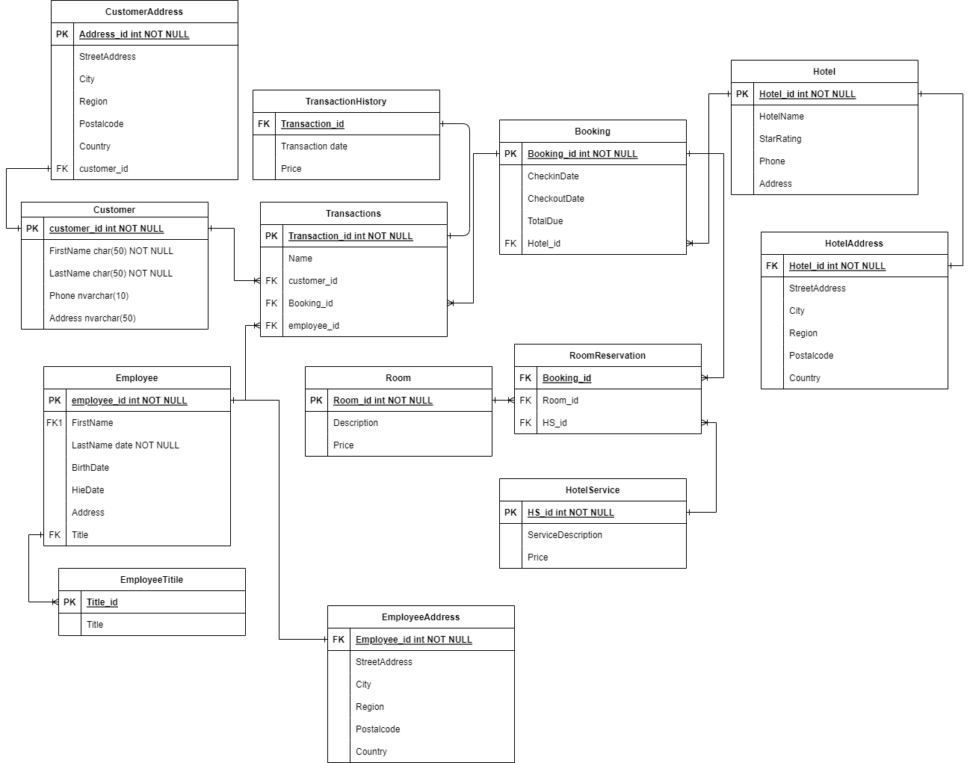

# Entity Identification and explanation:

## Employee:

|  |  |  |  |
| --- | --- | --- | --- |
|  | Column | Data Type | Description |
| PK | **Employee_id** | int | Uniquely identifies each employee |
|  | First Name | varchar | Employee's first Name |
|  | Last Name | varchar | Employee's Last Name |
|  | Birth Date | DateTime | Employee date of birth |
|  | Hie Date | DateTime | Employee Hire date |
|  | Address | nvarchar | Employee address |
| FK | Title | varchar | Employee title |

## EmployeeAddress:

|  |  |  |  |
| --- | --- | --- | --- |
|  | Column | Data Type | Description |
| FK | **Employee_id** | int | identifies each employee |
|  | Street Address | nvarchar | Employee address |
|  | City | nvarchar | City of occupancy |
|  | Region | nvarchar | Region of occupancy |
|  | Postal code | nvarchar | Mailing code |
|  | Country | nvarchar(50) | Country of occupancy |

## EmployeeTitle:

|  |  |  |  |
| --- | --- | --- | --- |
|  | Column | Data Type | Description |
| PK | Title_id | int | Uniquely identifies each title |
|  | Title | varchar | Records each Title |

## Customer:

|  |  |  |  |
| --- | --- | --- | --- |
|  | Column | Data Type | Description |
| PK | Customer_id | int | Uniquely identifies each customer |
|  | FirstName | varchar | Customer first Name |
|  | LastName | varchar | Customer Last Name |
|  | Phone No. | nvarchar | Customer phone number |
|  | Address | nvarchar | Customer address |

## CustomerAddress:

|  |  |  |  |
| --- | --- | --- | --- |
|  | Column | Data Type | Description |
| FK | **Customer_id** | int | identifies each employee |
|  | Street Address | nvarchar | Employee address |
|  | City | nvarchar | City of occupancy |
|  | Region | nvarchar | Region of occupancy |
|  | Postal code | nvarchar | Mailing code |
|  | Country | nvarchar(50) | Country of occupancy |

## Transactions:

|  |  |  |  |
| --- | --- | --- | --- |
|  | Column | Data Type | Description |
| PK | Transaction_id | int | Uniquely identifies each transaction made |
|  |  |  |  |
| FK | Customer_id | int | identifies each customer |
| FK | **employee_id** | int | identifies each employee |
| FK | Booking_id | int | identifies each Booking made |

## TransactionHistory:

|  |  |  |  |
| --- | --- | --- | --- |
|  | Column | Data Type | Description |
| FK | Transaction_id | int | identifies each transaction made |
|  | Transaction Date | DateTime | Records date of each transaction |
|  | Price | Money | Records amount made from each transaction |

## Booking:

|  |  |  |  |
| --- | --- | --- | --- |
|  | Column | Data Type | Description |
| PK | Booking_id | int | Uniquely identifies each Booking made |
|  | Check-in Date | DateTime | Records start date of booking |
|  | Checkout Date | DateTime | Records end date of booking |
|  | Total Due | Money | Records Total amount to be paid |
| FK | Hotel_id | int | Identify Hotel used for booking |

## Hotel:

|  |  |  |  |
| --- | --- | --- | --- |
|  | Column | Data Type | Description |
| PK | Hotel_id | int | Uniquely identifies each Hotel |
|  | Hotel Name | nvarchar | Records the Name of each Hotel |
|  | Star Rating | int | Records the Star Rating |
|  | Phone No. | nvarchar | Records the Phone number of each Hotel |
|  | Address | nvarchar | Records The Address of Each Hotel |

## HotelService:

|  |  |  |  |
| --- | --- | --- | --- |
|  | Column | Data Type | Description |
| PK | HS_id | int | Uniquely identifies each Hotel Service |
|  | Service Description | nvarchar(255) | Records information of each Service |
|  | Price | Money | Records the price of each Hotel Service |

## HotelAddress:

|  |  |  |  |
| --- | --- | --- | --- |
|  | Column | Data Type | Description |
| FK | **Hotel_id** | int | identifies each employee |
|  | Street Address | nvarchar | Employee address |
|  | City | nvarchar | City of occupancy |
|  | Region | nvarchar | Region of occupancy |
|  | Postal code | nvarchar | Mailing code |
|  | Country | Nvarchar(50) | Country of occupancy |

## Room:

|  |  |  |  |
| --- | --- | --- | --- |
|  | Column | Data Type | Description |
| PK | Room_id | int | Uniquely identifies each Room |
|  | Description | nvarchar(255) | Records information of each room |
|  | Price | Money | Records the price of each Room |

## RoomReservation:

|  |  |  |  |
| --- | --- | --- | --- |
|  | Column | Data Type | Description |
| FK | Booking_id | int | Links to bookings table |
| FK | Room_id | int | identifies Room chosen |
| FK | HS_id | int | identifies Hotel Service chosen |

# **List and description of objects in the database**

# **Tables**

1. Hotel
2. HotelAddress
3. Customer
4. CustomerAddress
5. Employee
6. EmployeeTitle
7. EmployeeAddress
8. Transactions
9. TransactionHistory
10. Room
11. RoomReservation
12. HotelService
13. Booking

# **Queries**

1. A query that displays employees and their titles
2. Transactions that have a price below average price
3. Transactions that have a price above average price
4. Country of customers that have the fewest transactions
5. Summary of Transactions displaying the name, number of transactions, date and average price

# **Other objects**

1. Trigger that informs which employee has a birthday today
2. Stored procedure that inserts a new employee
3. A function that computes additional total costs that arise if demand for rooms increase
4. Cursor showing the services available at a certain hotel for a specific booking
5. Cursor showing the Transactions made by a specific employee
6. View displaying transactions made and year of transactions